Additional Support for Learning (ASL)
Parent/Carer Conference
29 September 2016
1000-1400 hours
New Gorbals Parish Church
1 Errol Gardens, G5 0RA
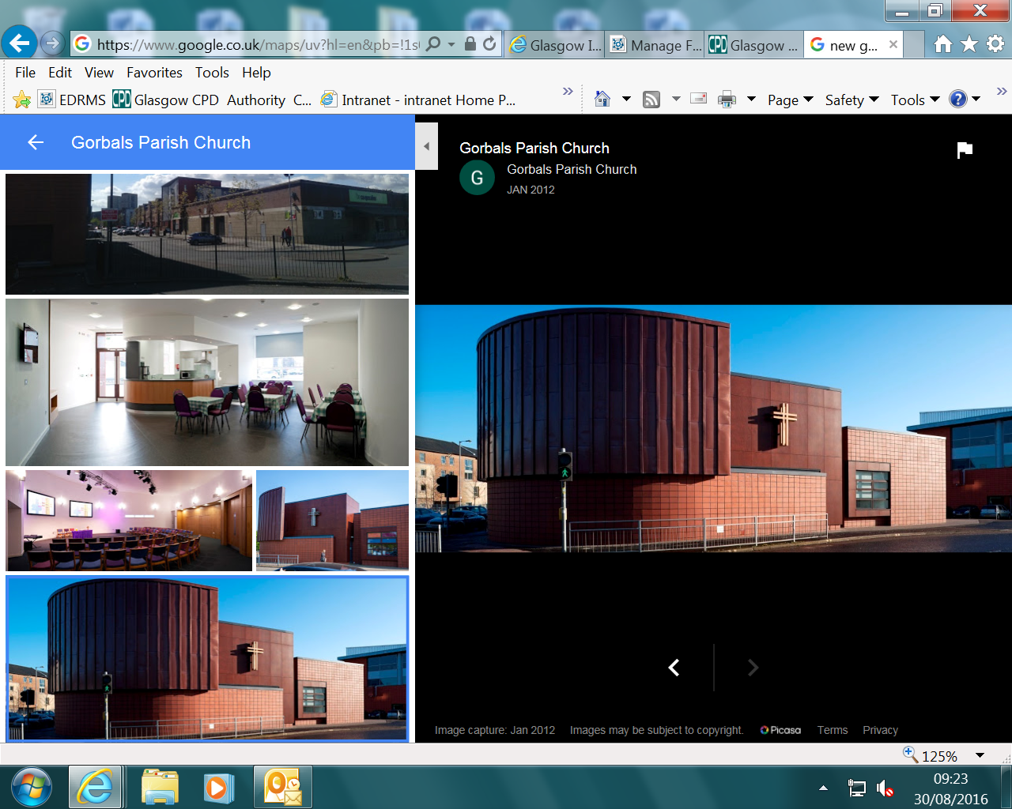

Dear Parents/Carers
You are warmly invited to this conference which will be made up of the following:
Keynote Speech from Colin Crawford, Head of Inclusion
Hot roll and drink, getting to know each other
Language and Communication Friendly Establishments Presentation and Workshop
Transitions and Pathways Presentation and Workshop
Lunch and opportunity to talk with Education Services/Educational Psychology staff
and ASL Parent/Carer Forum members

If you would like to come, please complete the information below and email or post in to the addresses shown.
This event has 80 parent/carer places on a first come, first served basis but please be assured that we will run it again should demand be high.
Presentations will also be filmed for our Glasgow City Council website. The formal part of the event will be looking at inclusion and meeting needs for all.
More specific questions and comments will be welcomed at the networking part from 1300 hours. We are delighted that Enquire will also be there to network and share information - http://enquire.org.uk/

Name(s):

Email Address:

Postal Address:

Telephone Number:

Dietary Requirements:

I have child/children in the following sector(s):

Please Tick
Early Years
Primary
Secondary
ASL Stand Alone
ASL Co-located

A question/comment I may like to share on the day is

Please return as soon as possible to:

Yvonne Keenan
Yvonne.Keenan@glasgow.gov.uk
Business Services – Directorate
City Chambers East Building
40 John Street
GLASGOW
G1 1JL
We look forward to hearing from you!

