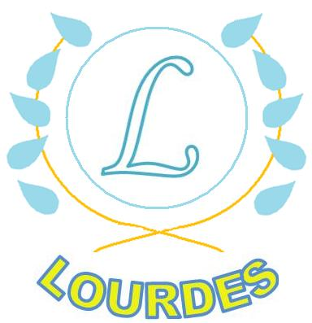
Reading Challenge Newsletter
Dear Parent/Guardian,
This year Lourdes Primary will focus strongly on ‘Reading for Enjoyment’. This project will be led by the school’s two Attainment Challenge Leaders of Learning (Mr Maxwell and Miss Currie). These teachers will be promoting Reading for Enjoyment as a whole school initiative, allowing the children to take part in a range of fun and exciting activities related to the enjoyment and choice aspect of reading. This newsletter will be shared regularly and will allow us to show off what our wonderful children are doing here at Lourdes Primary school.
Lending Library
Following from the success of the nursery, Primary One will be given the opportunity to visit the school lending library. The children will choose a book from a range of new and exciting texts and can take it home to enjoy. The Primary 7 students will take ownership of this library and will take full responsibility in running it, helping the children to choose a book and sign it in and out correctly.
Our Vision
Children will engage with and value reading as a lifelong skill.

Library Visits
We have now established a strong link with the local library in Cardonald. Each class will have an opportunity to visit the library and take part in a storytelling workshop. We hope to have every child in the school with their own library card and accessing the library regularly. We can do it!

Paired Reading
We are excited to be launching a ‘Paired Reading’ programme. This programme will allow one to one time with children through a relaxed and enjoyable reading experience. We would love to involve parents in this programme. Full training will be given by our staff! Please enquire at the office if you are interested. Thank you!

Golden Time
Golden time on a Friday afternoon will be full of fun! The children will now take part in a range of exciting activities based around reading for enjoyment.

