

2015-16

**Lourdes Primary School**

**Reporting for Parents/Carers**

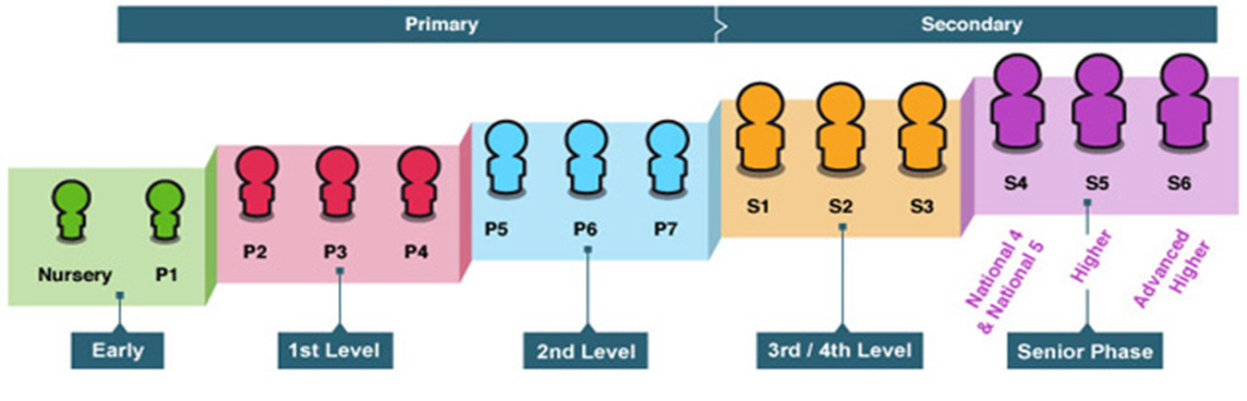

**Star Ratings – Attendance**

Lourdes Primary School operates on a Star Rating guide to inform parents/carers of a child’s attendance based on Glasgow City Council improving attendance rates. Last year the average attendance for children in schools in Glasgow was 93,9%. The Star Rating is based on the following percentages shown:

|  |  |
| --- | --- |
| **\*\*\*\*\*** | Excellent (100%) |
| **\*\*\*\*** | Very Good (99% -94%) |
| **\*\*\*** | Good (93% - 80%) |
| **\*\*** | Satisfactory (79% - 70%) |
| **\*** | Unsatisfactory (69% - ) |

**Star Ratings – Effort**

Lourdes Primary School operates on a Star Rating guide to inform parents/carers of a child’s effort in each curricula area. The Star Rating is scored according to the following scale:

|  |  |
| --- | --- |
| **\*\*\*\*\*** | Excellent |
| **\*\*\*\*** | Very Good |
| **\*\*\*** | Good |
| **\*\*** | Satisfactory |
| **\*** | Unsatisfactory |

**Curriculum for Excellence**

The path most children and young people are expected to follow through the levels reflects the stages of maturation of children and young people and the changing ways in which they engage with learning as they develop. Some children and young people will start learning at these levels earlier and others later, depending upon individual needs and aptitudes. The framework is however designed to be flexible in order to permit careful planning for those with additional support needs, including those who, for example, have a learning difficulty and those who are particularly able or talented.