

Lourdes Nursery Class




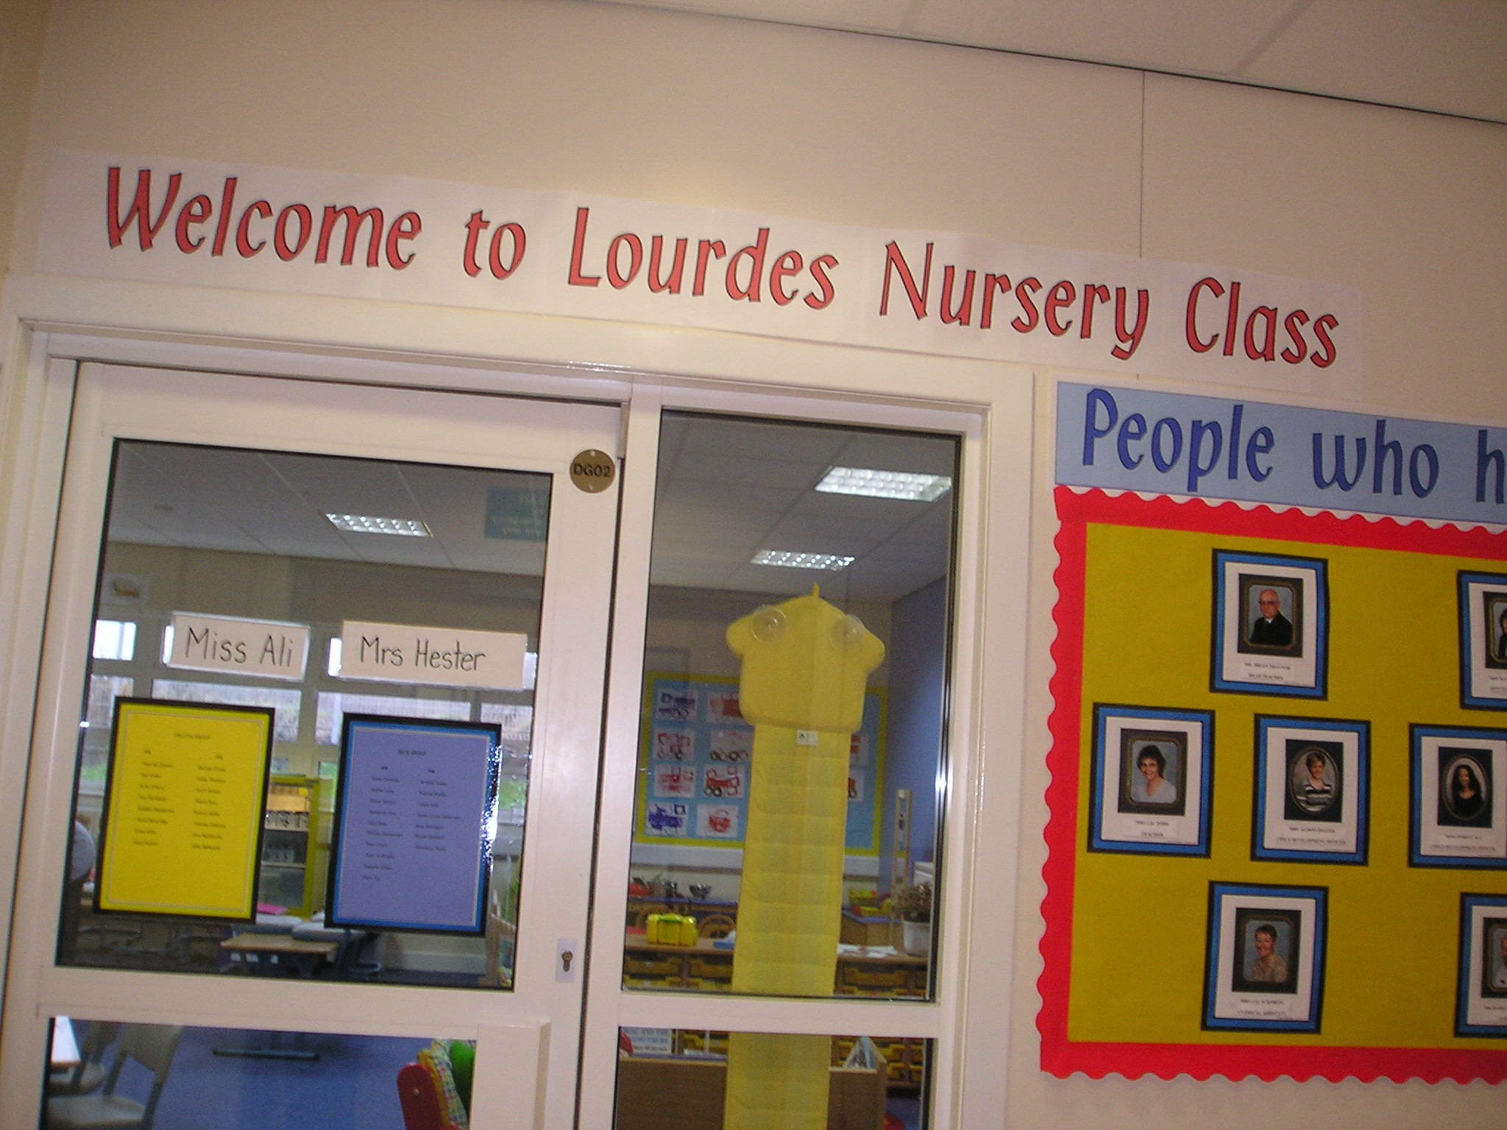

2014
Nursery Class Handbook

General Information

Address: Lourdes Primary School
150 Berryknowes Rd,
Cardonald,
Glasgow.
G52 2DE

Tel: 0141 882 2305

Fax No: 0141 891 5926

Web Address: www.lourdes-pri.co.uk

Daily Sessions: Morning: 8.45am – 11.55am

Afternoon: 12.40pm – 3.50pm

Statement of Aims

In Lourdes Nursery Class we aim to create an environment where both children and parents feel cared for, valued and secure; in which children are helped to develop positive attitudes towards learning experiences and each other.

These aims are achieved by:
- Taking time to get to know parents, as well as acquiring the most thorough knowledge possible of the individual child through observation and interaction with each other;
- Ensuring each child receives a broad and balanced curriculum that matches the individual needs;
- Valuing the contribution of the individual child regardless of sex, disability or race and fostering positive attitudes towards cultural diversity;
- Fostering genuine partnership with parents through workshops and formal/informal meetings;
- Ensuring that each child’s time at Lourdes Nursery Class will be happy and will be a good foundation for life.

About Our Nursery

Lourdes Nursery Class is an official Glasgow City Council Education establishment providing for pre school children and is part of Lourdes Primary School. The nursery class is non-denominational. We respect and welcome children and parents of all religious faiths and beliefs.
The nursery class offers part time places only – 40 places in the morning and 40 in the afternoon – for 3-5 year olds.

Hours

It is important that you arrive promptly at the start of each session so that each child can fully participate in the planning of activities with the children in their group and with your child’s Key Worker.

Admission Policy

All nursery places are allocated in line with the Council’s Admission Policy and the aim to provide a Nursery placement for all children in their pre-school year. The Head Teacher will be happy to advise you how this policy operates when you apply for a place for your child. A leaflet detailing the Council’s policy is available. If you want a copy, please ask for one.

An admission Panel meets at regular intervals throughout the year to decide how Nursery places will be allocated.

Children’s names can go on the register of application after their second birthday.

Register of Applicants
A register of all applicants will be kept by the Head of Establishment and the information contained in the applications will be considered by the Admissions Panel to assist in the allocation of places.

Please note that the length of time a child’s name has been on the register will not affect the child’s priority for admission.

Parents can ask to see their application form at any time. If circumstances change which affect the application you should speak to the Head of Establishment.

The school will accept names of children after their second birthday.

Enrolling Procedure

Children and parents are usually invited to visit the Nursery before their start date. At this visit necessary forms are filled in, the children look round and join the play. Information about your child’s actual start date, their group and their key worker will be available then. We have a flexible settling in programme when parents join their children in the playroom.

This gives you a chance to get to know us and how we work. Gradually you will be allowed away for a short time, this continues until your child is settled and happy. The time this takes is dependent on the needs of the individual children and parents.

Photographs

At various times during the year we will take photographs or DVD of the children to keep in their records or display in the foyer. If you any concerns regarding this please speak to your child’s key worker.

Toy Fund

Parents are asked for a voluntary contribution of £2.50 per child per week. These funds are used to replace damaged or missing toys, provide the ingredients for baking and play dough. The money is also used to pay for toy fund treats e.g. theatre groups, end of term parties, Santa Claus etc. Our clerical assistant will collect contributions on Mondays and Fridays at the desk in the foyer.

Attendance

Regular attendance at Nursery is encouraged and children make friends and settle more easily if a regular routine is established. We ask you to let us know if your child is ill or going to be off Nursery. If you do not let us know about your child’s absence a member of staff will phone home as part of our Attendance Policy.

Snacks and the Promotion of Healthy Living

The children are given milk to drink and water is offered if a child cannot drink milk. The snack is a variety of fresh seasonal fruit except for special occasions and celebrations. The children are free to choose and encouraged to try but not made to eat anything they do not want.

Suitable Clothing

Children have the best fun when they are doing messy work. We will always try to make sure they wear aprons but accidents happen so please dress your child in suitable clothes. Jewellery or outdoor shoes should not be worn. Please also make sure that your child has suitable outdoor clothing for outdoor play or if an outing is planned.

Birthdays

If you wish your child to celebrate his/her birthday with their friends in Nursery School, please send in a small birthday cake preferably a sponge cake. Your child’s birthday will be celebrated and a small present given from all the children and staff.

Gym and Physical Activity

In addition to our physical area we also are timetabled for the school gym. Please note that for safety reasons children are not allowed on any equipment or apparatus unless supervised by a member of staff. Please ensure that your child has suitable footwear wearing appropriate footwear and clothing on that day.

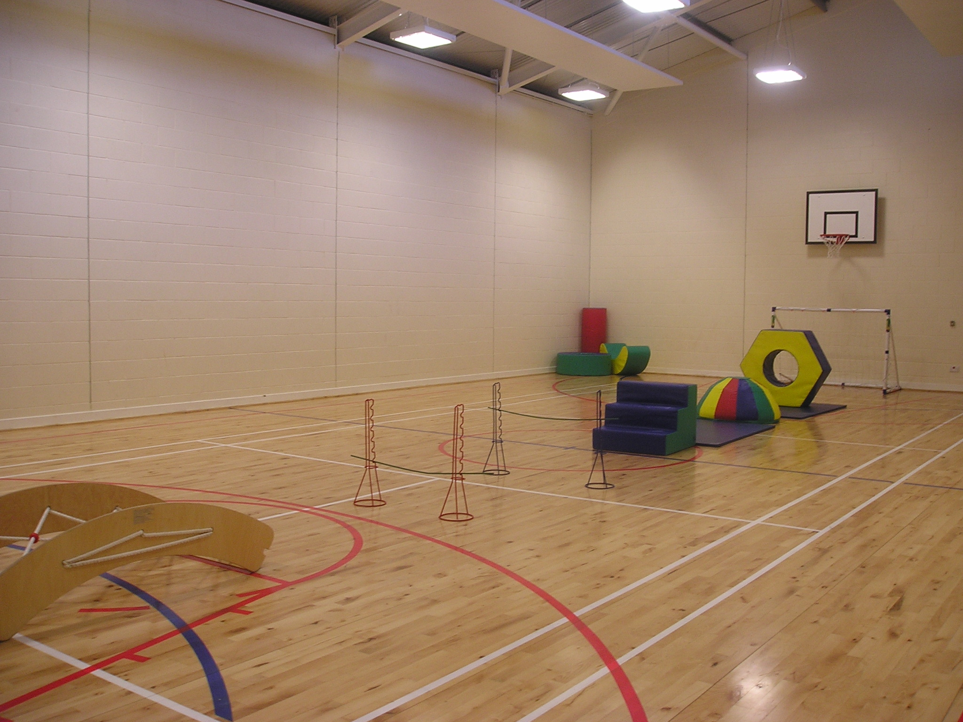

The Playground

When the children are playing outside we ask parents to treat our playground as an extension of our learning environment.

Please refrain from smoking, eating or talking loudly.

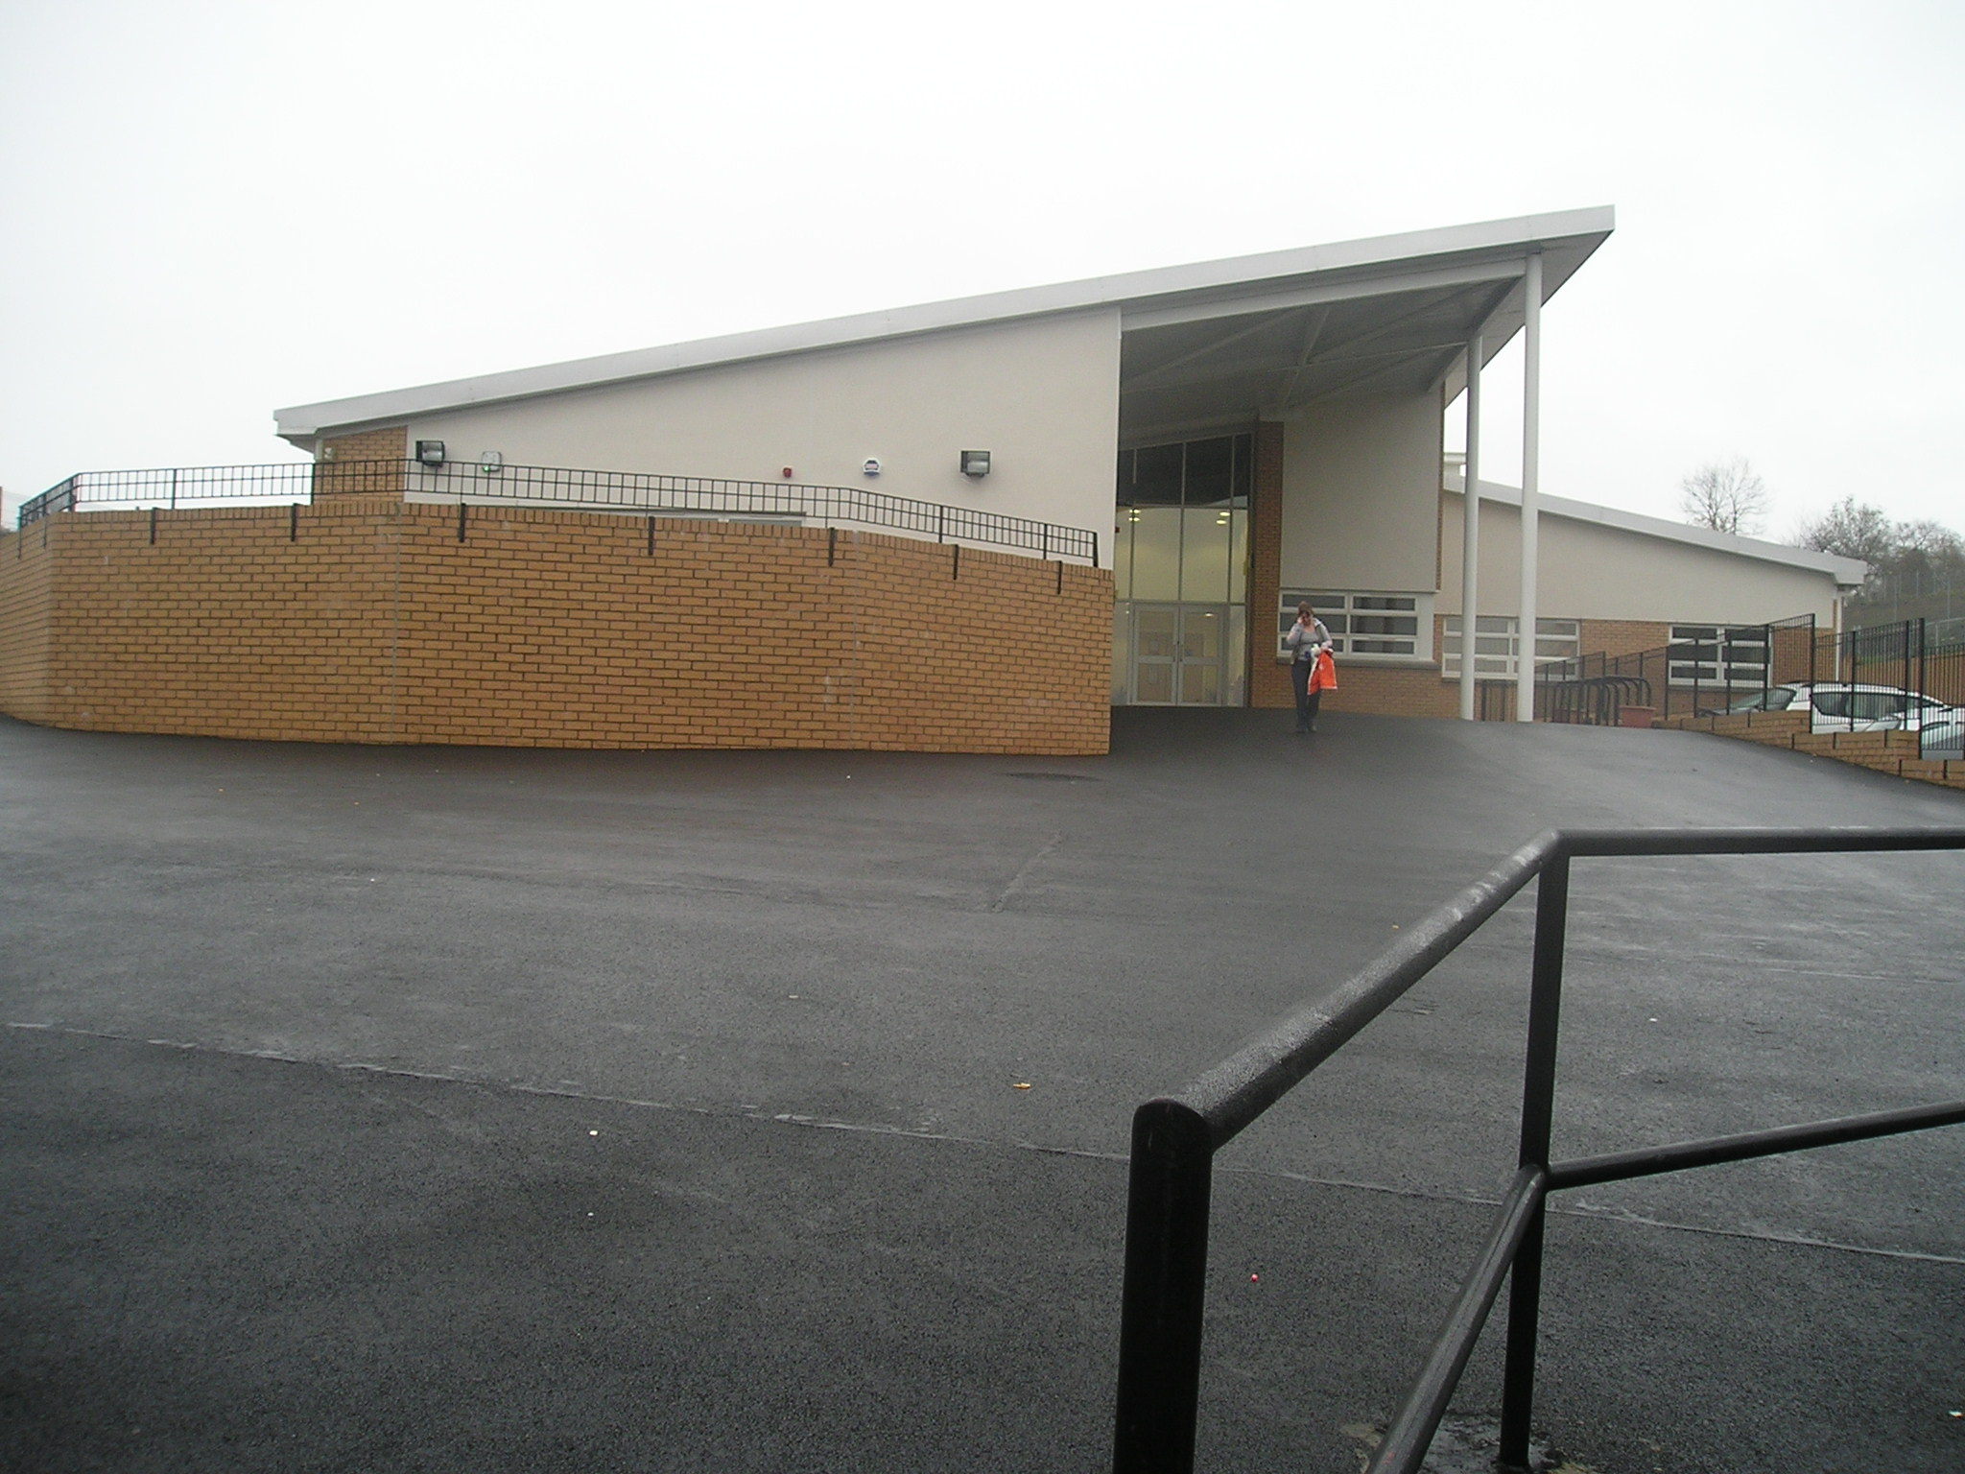

Arrival and Collection of Children

It is expected that a responsible adult will bring a child to and from the Nursery.

In the interests of your child’s safety you should make a point of telling the Head of Establishment if he or she is to be collected by someone not known to the Head of Establishment or staff members. Parents are requested to provide a photograph of any person expected to collect their child. This avoids difficult situations when a child cannot be allowed to leave with an adult who is a stranger to the staff.

Insurance

Sometimes children like to bring something special or new to Nursery for their friends to see. However, parents should ensure that valuable items are not left at School, particularly as the Authority has no insurance to cover the loss of such personal items. Claims submitted are likely to be met only where the Authority can be shown to have been negligent.

Excursions and Consent Forms

When outings of excursions for children are planned, the Head of Establishment or a member of staff will advise you in advance. You will be asked to complete consent forms, which give your permission for your child’s participation. Please note that children cannot take part in outings unless completed consent forms have been submitted by their parent/guardian.

Transport

Transport is not normally provided for children attending pre-five establishments. The Council may, however provide transport to and from Nursery for children with special needs who may require to travel some distance to take up their placement. A few establishments have their own transport but this is exceptional and generally parents should make their own travel arrangements.

Emergency Closure Arrangements

The Nursery will be opened on the times already outlined, but on extreme occasions there may be circumstances which mean the Nursery class has to close.

Establishments may be affected by, for example, severe weather, transport problems, staff shortages, industrial action, power failures or difficulties with fuel supplies. If this happens, we will do all we can to let you know about the detail of closure and re-opening. We may keep in touch by letter, telephone, in the press and on local radio.

Emergency Contacts

Parents whose children are in Nursery are asked where possible to provide the Establishment with the names, addresses and telephone numbers of two contact persons for use in case of emergency.

You are also asked to keep the Nursery up-to-date with any changes in this information.

Toy Information

Following Glasgow City Councils policy we ask parents not to allow children to bring toys that are associated with violence on to Council property (this includes the playground).

Medical Information

Medication:

If your child is in need of medication during his/her time at Nursery you should discuss his/her requirements with the child’s key worker. A record will be kept of information given regarding the child’s condition, signs and symptoms and any other relevant information. This record will be kept in the child’s medication wallet.
Only prescribed drugs will be given at the discretion of the Head of the School and you will need to fill in a form, which authorises Nursery Staff to administer the drugs to your child. The school First Aider will give you the necessary form to complete.

Head Lice

All parents are asked to examine their child’s hair every week using conditioner and a fine toothcomb. Children should not attend Nursery while infested, however, as soon as treatment has been applied they should return.

If Your Child Becomes Ill

The Establishment would welcome a telephone call if you child were not able to attend Nursery on a particular day.

If your child becomes ill while at Nursery we will make him/her comfortable and isolate them if necessary, while trying to contact you if we feel home is the best place for the child.

Minor Accidents and Upsets

A cold compress will be applied to minor bumps or bruises. More serious wounds or medical emergencies are taken to the Southern General Hospital by a member of staff while every effort is made to contact the parents.



Visit to the Establishment by Medical Staff

Throughout the year there are dental and vision checks. Parental consent must be given before any checks are carried out. We often have visits from dental hygienists who give the children talks on how to care for their teeth.

Settling In Period

During this time parents will be asked to remain in the playroom on the first day to work in partnership with the staff to familiarise the child with his or her new environment. The staff will advise parents on how this should continue over the next few days e.g. remaining in the building but in another room. This procedure will vary depending on the child.

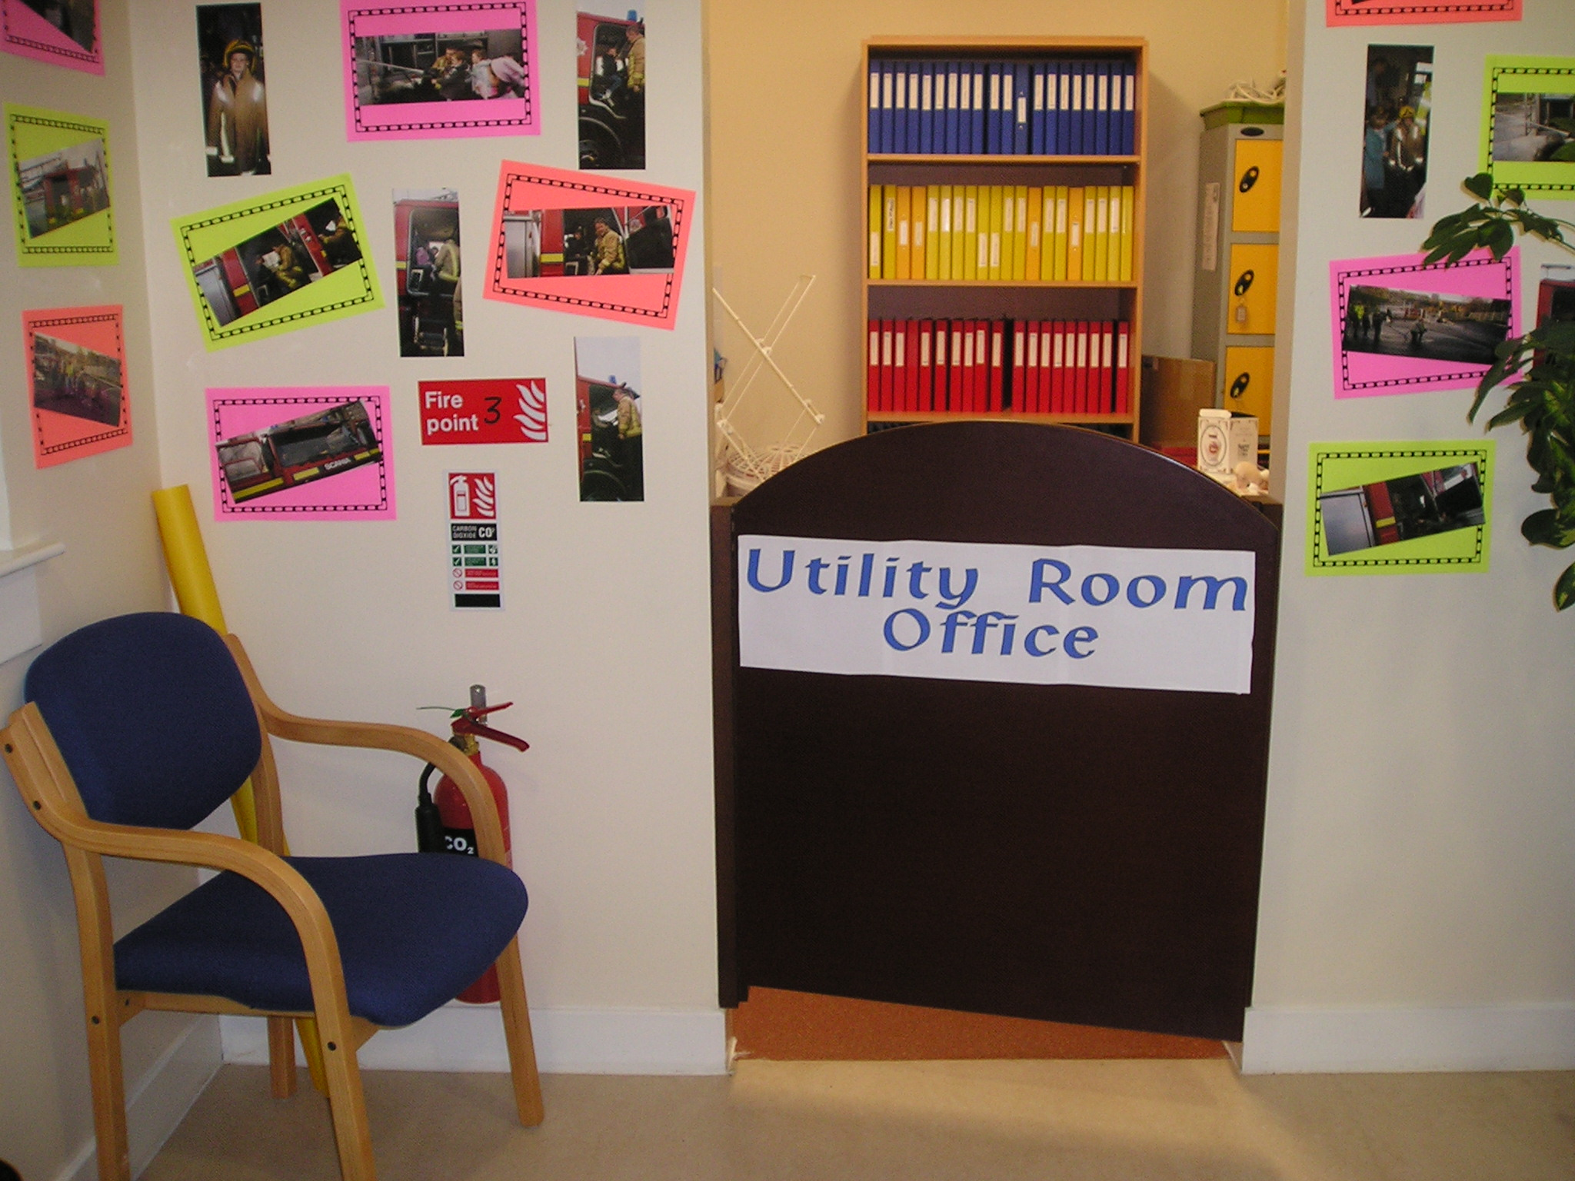

Nursery Routine

Please arrive for the morning session between 8.45am – 9.00am and 12.40 – 12.55 for the afternoon session. If on occasion you are later please ring the doorbell and wait until a member of staff is available to answer the door.

When bringing your child to the Nursery Class please help your child hang up his/her coat and change his/her shoes and then accompany your child to the member of staff with responsibility for the group. Similarly when collecting your child please wait in the Nursery Class entrance area until the members of staff open the doors to the playrooms. Children will be handed over to an adult known to the staff. Parents will be asked to provide a photograph of all the adults responsible for collecting your child.

Parents must inform the nursery class staff in advance of any change in the collection of their child.

Curriculum For Excellence

At Lourdes Nursery Class we are very excited about our curriculum and aim to ensure all learners are developing and building on the knowledge and skills they need to flourish in life, learning and work.

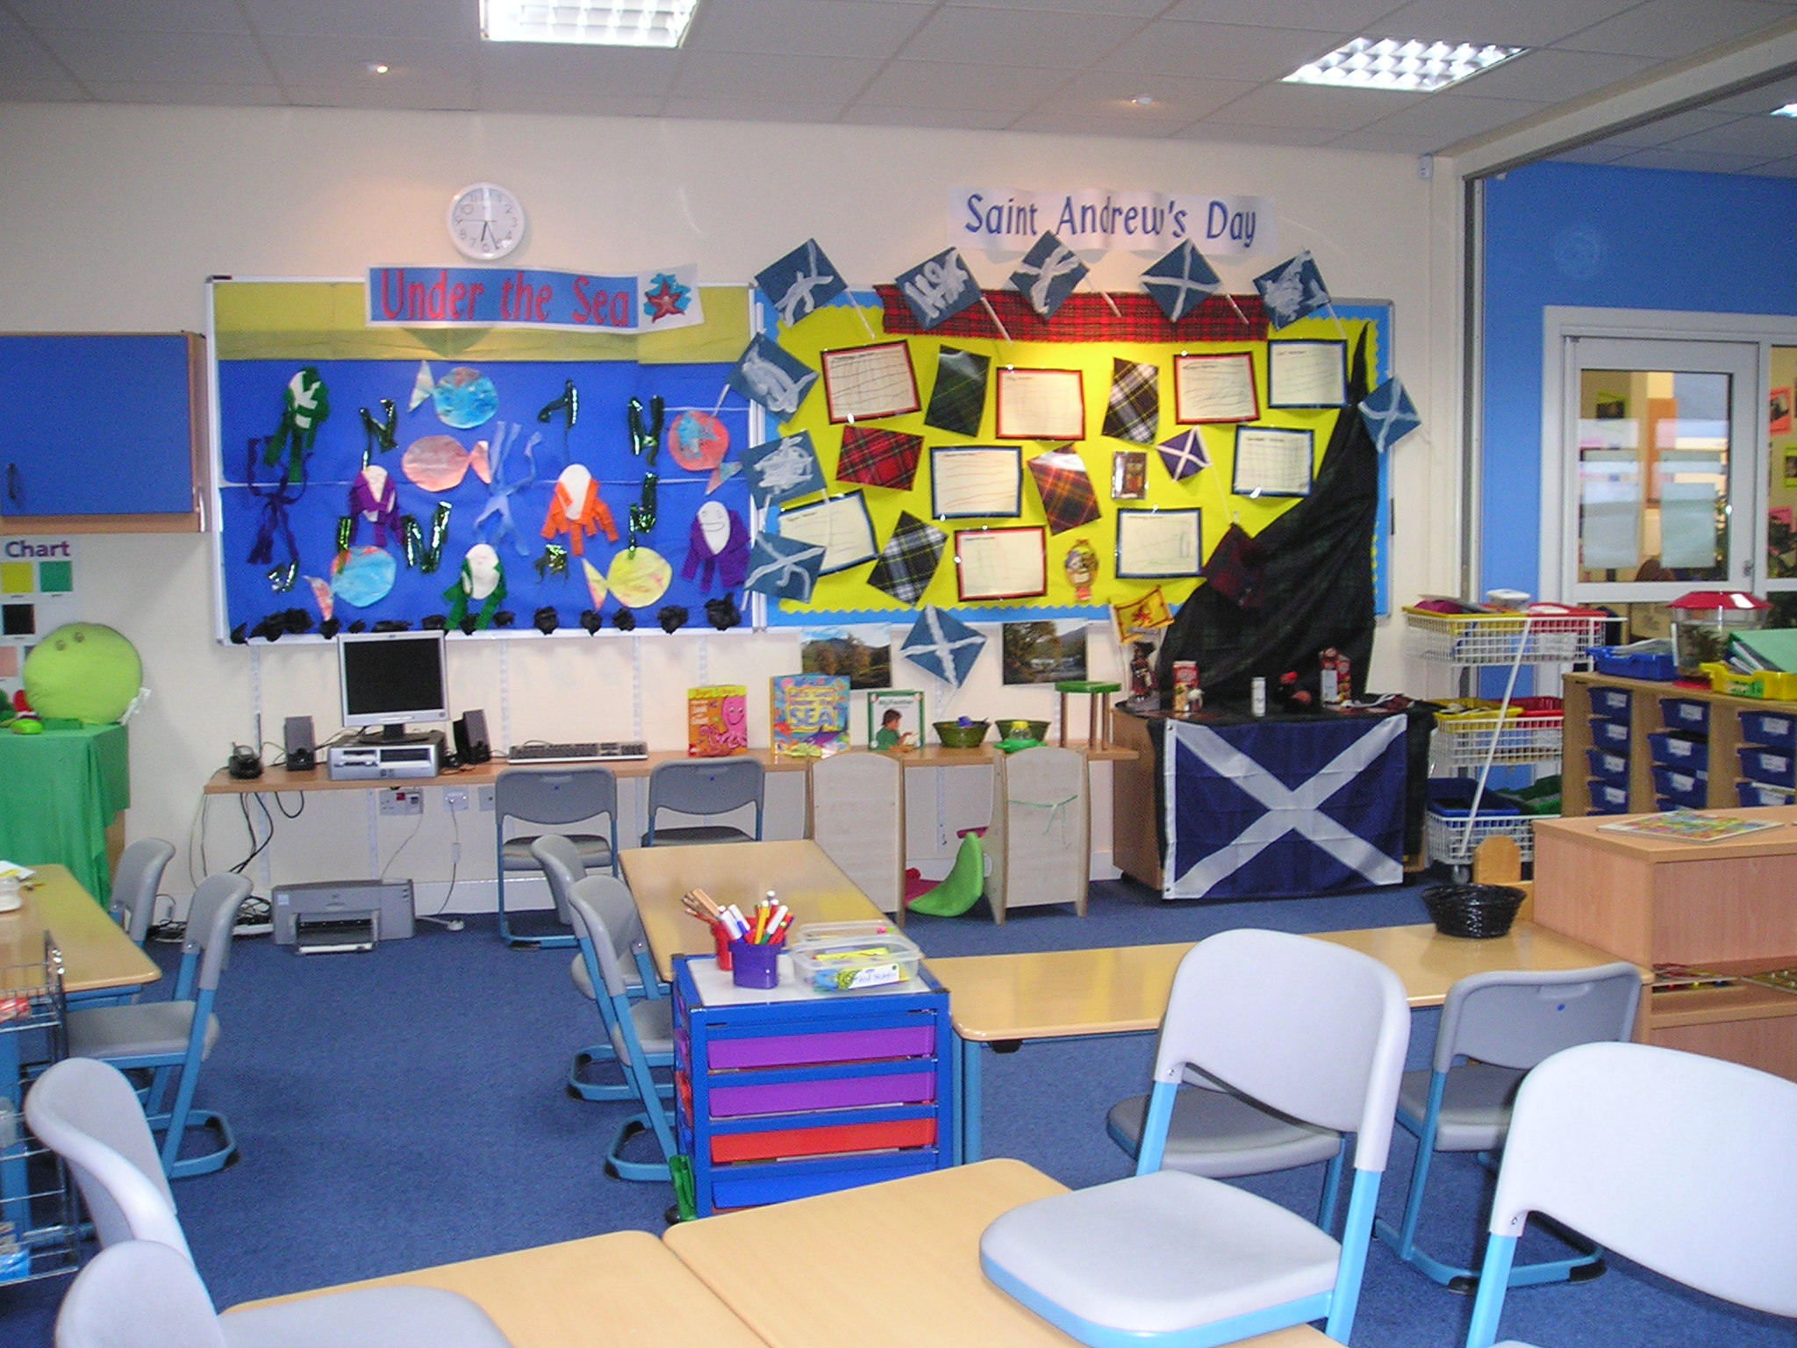
Our aim is to enable all learners to become:
- Responsible Citizens
- Effective Contributors
- Successful Learners
- Confident Individuals

The curriculum is designed on the basis of the following principles:

Challenge and enjoyment
Children and young people should find their learning challenging, engaging and motivating. The curriculum should encourage high aspirations and ambitions for all.
At all stages, learners of all aptitudes and abilities should experience an appropriate level of challenge, to enable each individual to achieve his or her potential. They should be active in their learning and have opportunities to develop and demonstrate their creativity. There should be support to enable children and young people to sustain their effort.

Breadth
All children and young people should have opportunities for a broad, suitably weighted range of experiences. The curriculum should be organised so that they will learn and develop through a variety of contexts within both the classroom and other aspects of school life.

Progression
Children and young people should experience continuous progression in their learning from 3 to 18 within a single curriculum framework.
Each stage should build upon earlier knowledge and achievements. Children should be able to progress at a rate which meets their needs and aptitudes, and keep options open so that routes are not closed off too early.
Progression in the experiences and outcomes

Depth
There should be opportunities for children to develop their full capacity for different types of thinking and learning. As they progress, they should develop and apply increasing intellectual rigour, drawing different strands of learning together, and exploring and achieving more advanced levels of understanding.

Personalisation and choice
The curriculum should respond to individual needs and support particular aptitudes and talents. It should give each child and young person increasing opportunities for exercising responsible personal choice as they move through their school career.
Once they have achieved suitable levels of attainment across a wide range of areas of learning, the choice should become as open as possible. There should be safeguards to ensure that choices are soundly based and lead to successful outcomes.

Coherence
Taken as a whole, children and young people's learning activities should combine to form a coherent experience. There should be clear links between the different aspects of children and young people's learning, including opportunities for extended activities which draw different strands of learning together.

Relevance
Children and young people should understand the purposes of their activities. They should see the value of what they are learning and its relevance to their lives, present and future.
There are eight curriculum areas which allow us to set out and organise the experiences and outcomes.
Each area contributes to the four capacities.

Expressive arts
Experiences and outcomes

Experiences in the expressive arts involve creating and presenting and are practical and experiential. Evaluating and appreciating are used to enhance enjoyment and develop knowledge and understanding.

My learning in, through and about the expressive arts:

- enables me to experience the inspiration and power of the arts
- recognises and nurtures my creative and aesthetic talents
- allows me to develop skills and techniques that are relevant to specific art forms and across the four capacities
- provides opportunities for me to deepen my understanding of culture in Scotland and the wider world
- is enhanced and enriched through partnerships with professional arts companies, creative adults and cultural organisations.

Health and wellbeing
Experiences and outcomes

Learning in health and wellbeing ensures that children and young people develop the knowledge and understanding, skills, capabilities and attributes which they need for mental, emotional, social and physical wellbeing now and in the future.

Each establishment, working with partners, should take a holistic approach to promoting health and wellbeing, one that takes account of the stage of growth, development and maturity of each individual, and the social and community context.

I can expect my learning environment to support me to:

- develop my self-awareness, self-worth and respect for others
- meet challenges, manage change and build relationships
- experience personal achievement and build my resilience and confidence
- understand and develop my physical, mental and spiritual wellbeing and social skills
- understand how what I eat, how active I am and how decisions I make about my behaviour and relationships affect my physical and mental wellbeing
- participate in a wide range of activities which promote a healthy lifestyle
- understand that adults in my school community have a responsibility to look after me, listen to my concerns and involve others where necessary
- listen to my concerns and involve others where necessary
- learn about where to find help and resources to inform choices
- assess and manage risk and understand the impact of risk-taking behaviour
- reflect on my strengths and skills to help me make informed choices when planning my next steps
- acknowledge diversity and understand that it is everyone’s responsibility to challenge discrimination.

Literacy and English

Experiences and outcomes

The development of literacy skills plays an important role in all learning.

I develop and extend my literacy skills when I have opportunities to:

- communicate, collaborate and build relationships
- reflect on and explain my literacy and thinking skills, using feedback to help me improve and sensitively provide useful feedback for others
- engage with and create a wide range of texts in different media, taking advantage of the opportunities offered by ICT
- develop my understanding of what is special, vibrant and valuable about my own and other cultures and their languages
- explore the richness and diversity of language, how it can affect me, and the wide range of ways in which I and others can be creative
- extend and enrich my vocabulary through listening, talking, watching and reading.

In developing my English language skills:

- I engage with a wide range of texts and am developing an appreciation of the richness and breadth of Scotland’s literary and linguistic heritage
- I enjoy exploring and discussing word patterns and text structures.

Numeracy and Mathematics
Experiences and outcomes

My learning in mathematics enables me to:

- develop a secure understanding of the concepts, principles and processes of mathematics and apply these in different contexts, including the world of work
- engage with more abstract mathematical concepts and develop important new kinds of thinking
- understand the application of mathematics, its impact on our society past and present, and its potential for the future
- develop essential numeracy skills which will allow me to participate fully in society
- establish firm foundations for further specialist learning
- understand that successful independent living requires financial awareness, effective money management, using schedules and other related skills
- interpret numerical information appropriately and use it to draw conclusions, assess risk, and make reasoned evaluations and informed decisions
- apply skills and understanding creatively and logically to solve problems, within a variety of contexts
- appreciate how the imaginative and effective use of technologies can enhance the development of skills and concepts.

Religious and moral education
Experiences and outcomes

Learning through religious and moral education enables me to:

- recognise religion as an important expression of human experience
- learn about and from the beliefs, values, practices and traditions of Christianity and the world religions selected for study, other traditions and viewpoints independent of religious belief
- explore and develop knowledge and understanding of religions, recognising the place of Christianity in the Scottish context
- investigate and understand the responses which religious and non-religious views can offer to questions about the nature and meaning of life
- recognise and understand religious diversity and the importance of religion in society
- develop respect for others and an understanding of beliefs and practices which are different from my own
- explore and establish values such as wisdom, justice, compassion and integrity and engage in the development of and reflection upon my own moral values
- develop my beliefs, attitudes, values and practices through reflection, discovery and critical evaluation
- develop the skills of reflection, discernment, critical thinking and deciding how to act when making moral decisions
- make a positive difference to the world by putting my beliefs and values into action
- establish a firm foundation for lifelong learning, further learning and adult life.

Sciences

Experiences and outcomes

The sciences framework provides a range of different contexts for learning which draw on important aspects of everyday life and work.
Learning in the sciences will enable me to:

- develop curiosity and understanding of the environment and my place in the living, material and physical world
- demonstrate a secure knowledge and understanding of the big ideas and concepts of the sciences
- develop skills for learning, life and work
- develop the skills of scientific inquiry and investigation using practical techniques
- develop skills in the accurate use of scientific language, formulae and equations
- apply safety measures and take necessary actions to control risk and hazards
- recognise the impact the sciences make on my life, the lives of others, the environment and on society
- recognise the role of creativity and inventiveness in the development of the sciences
- develop an understanding of the Earth’s resources and the need for responsible use of them
- express opinions and make decisions on social, moral, ethical, economic and environmental issues based upon sound understanding
- develop as a scientifically-literate citizen with a lifelong interest in the sciences
- establish the foundation for more advanced learning and future careers in the sciences and the technologies.

Social studies
Experiences and outcomes

Learning in the social studies will enable me to:

- develop my understanding of the history, heritage and culture of Scotland, and an appreciation of my local and national heritage within the world
- broaden my understanding of the world by learning about human activities and achievements in the past and present
- develop my understanding of my own values, beliefs and cultures and those of others
- develop my understanding of the principles of democracy and citizenship through experience of critical and independent thinking
- explore and evaluate different types of sources and evidence
- learn how to locate, explore and link periods, people and events in time and place
- learn how to locate, explore and link features and places locally and further afield
- engage in activities which encourage enterprising attitudes
- develop an understanding of concepts that stimulate enterprise and influence business
establish firm foundations for lifelong learning and for further specialised study and careers.

Technologies
Experiences and outcomes

The technologies framework provides a range of different contexts for learning that draw on important aspects of everyday life and work.

It includes creative, practical and work-related experiences and outcomes in business, computing science, food, textiles, craft, design, engineering, graphics and applied technologies.

Learning in the technologies enables me to:

- develop an understanding of the role and impact of technologies in changing and influencing societies
- contribute to building a better world by taking responsible, ethical actions to improve my life, the lives of others and the environment
- gain the confidence and skills to embrace and use technologies now and in the future, at home, at work and in the wider community
- become an informed consumer and producer who has an appreciation of the merits and impacts of products and services
- be capable of making reasoned choices relating to the environment, sustainable development and ethical, economic and cultural issues
- broaden my understanding of the role that information and communications technology (ICT) has in Scotland and in the global community
- broaden my awareness of how ideas in mathematics and science are used in engineering and the technologies
- experience work-related learning, and establish firm foundations for lifelong learning, and specialised study and careers.

It is important to remember that as children and young people play and learn they will develop an interest, confidence and enjoyment in ICT skills that can be transferred and applied in different learning contexts.
Learning Through Play
Through play, they can learn scientific concepts, such as what plants need to grow; mathematical concepts, for example, fitting blocks together to build a tower; literacy skills, such as looking for signs outdoors; technology skills, including scanning their artwork and emailing it to friends and family.
In this way, children learn how to:
• Work in partnership with others
• Express themselves
• Build their independence
• Make sense of their experiences
• Manipulate materials
• Test out new knowledge
• Develop new skills
• Make choices and decisions
• Solve problems… and lots more.

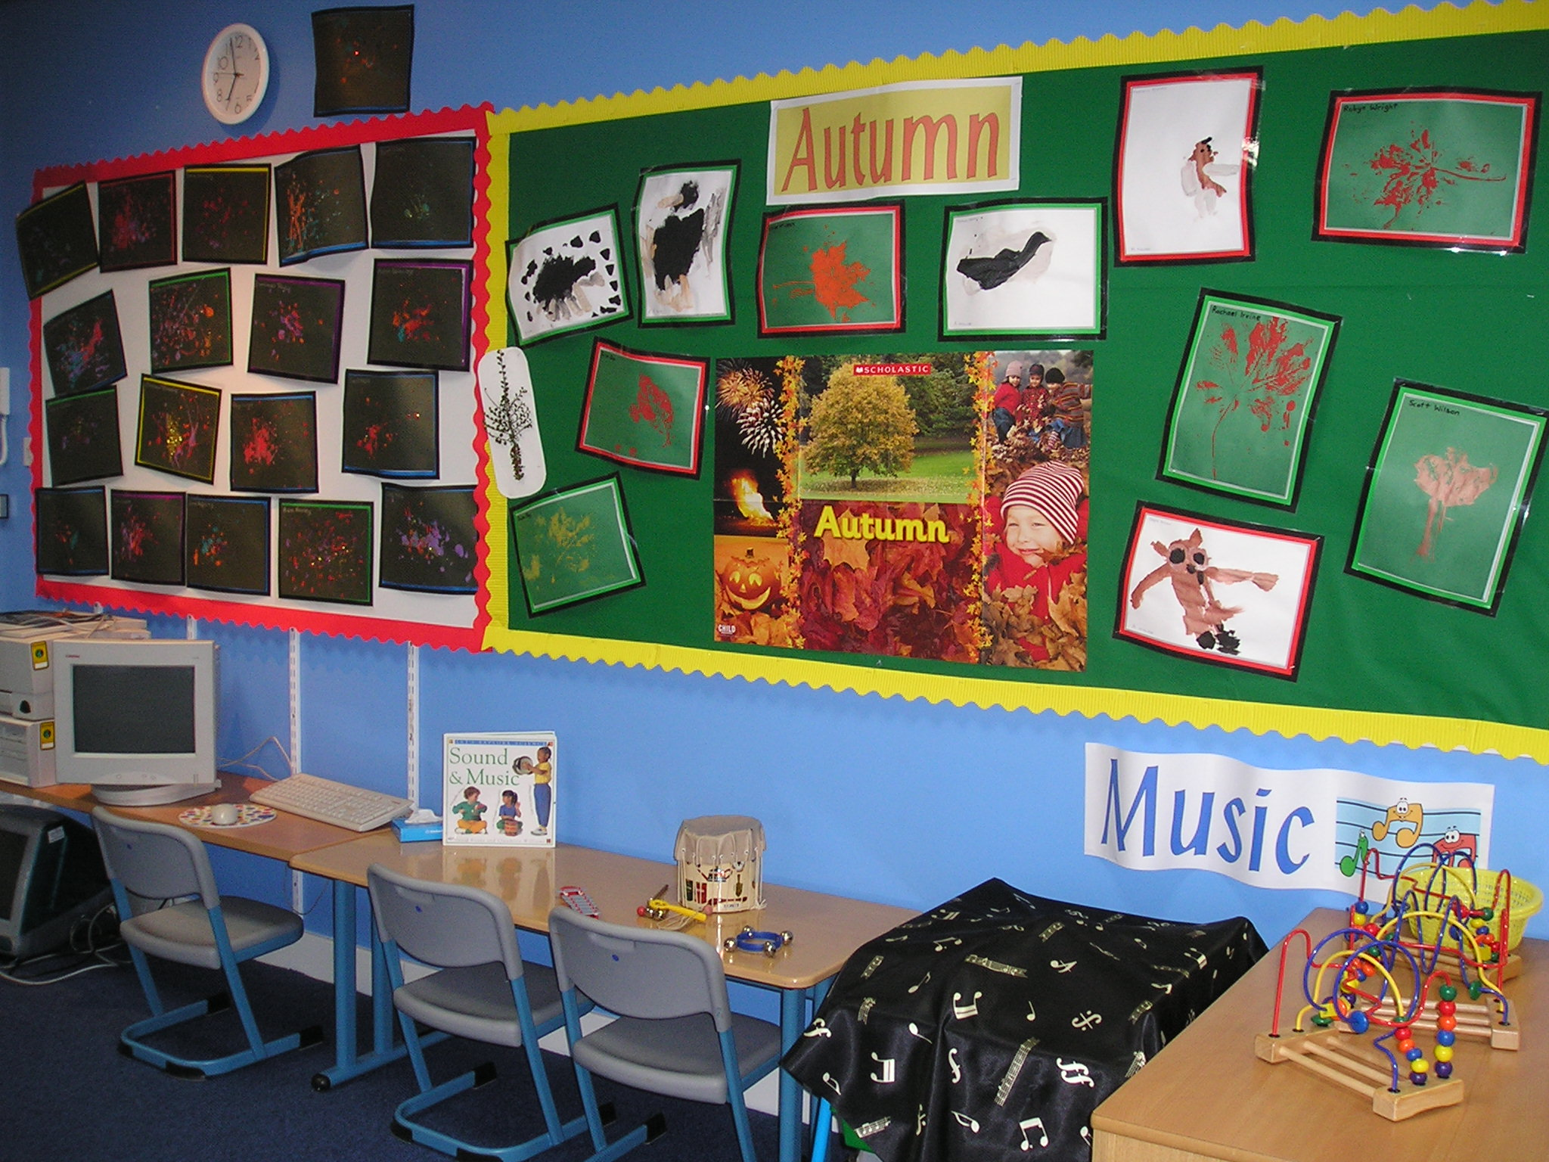

Active Learning
Active learning within Curriculum for Excellence doesn’t mean that children are actively running around! It is learning that engages children and challenges their thinking.
Motivated children who are actively engaged with tasks that have a clear purpose will retain and learn more and will be more likely to transfer the knowledge and be able to apply it in different situations.
Right from the outset, young children will be partners in the learning process; actively participating in the planning, shaping and directing of their own learning.
With sensitive adult support they’ll learn how to make informed choices, take responsibility for their own learning and offer ideas for improvements.

Finding out about your child’s progress
As staff form a relationship with your child by getting to know their strengths and preferences, they will consult regularly with you to create a joint record of your child’s progress.
This could include:
• Observing your child’s activities and tasks
• Notes about how happy and settled they are
• Information gained by asking questions and listening carefully to their responses
• Examples of drawings, writing and artwork
• Something they’ve made or produced
Staff will use this; along with any information you share to plan the next steps in your child’s learning. This record will also be a basis for regular discussion with you, along with more informal day-to-day contact.

Working Together to Support Learning

It is important that a relationship built on mutual trust and understanding is established between parents and staff. We aim to create a welcoming and inviting environment where parents feel comfortable to approach the Head Teacher and staff with any concerns. We operate a ‘key-worker’ system where each member of staff has responsibility for her own group of children and their parents. Staff also work as part of a team, so people who need to know share information. We also liase with other professional agencies such as Psychological Services, Speech and Language therapists etc.

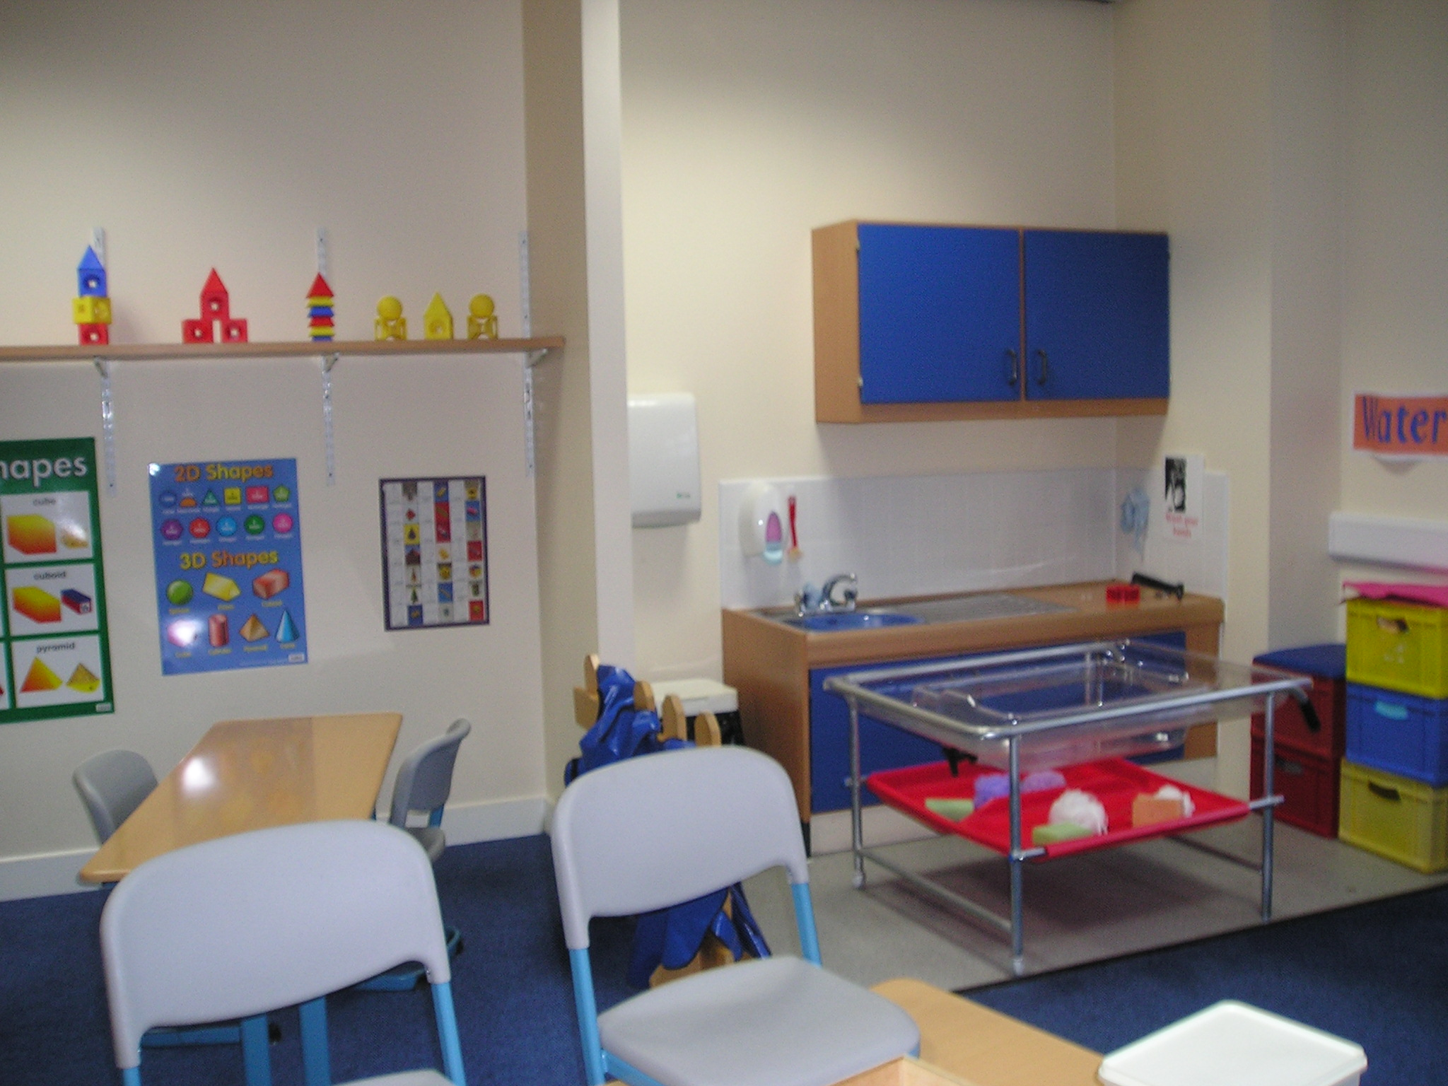

Communication

Effective communication between home and nursery is essential to the well being of the child. Therefore, we will keep you informed of events and activities in the following ways:
- Informal chats/discussions
- Parent Evenings
- Our Noticeboard
- Newsletters
- The Nursery Handbook



Working Together to Promote Positive Behaviour

All staff will strive to encourage the kind of behaviour from children which includes:
- Respecting others
- Helping to take care of the nursery resources and property
- Accepting authority of the adults in charge
- Observing the safety rules
- Being willing to share and take turns
- Taking responsibility for their own behaviour

Lending Library

The Lending Library is open one day a week in the school hall. The children have the opportunity to borrow from a wide selection of books. The library is organised by parents of the nursery on a volunteer rota basis.

Nursery Policies

All nursery policies are regularly updated and reviewed. A set of policies is kept in the Nursery Foyer and parents are more than welcome to view them at anytime. Please do not hesitate to ask a member of staff if you require any further information.

Suggestions and Complaints:

We are always anxious to maintain and improve our service. If you have any suggestion to make about the service, please contact the Head of Establishment in the first instance. Similarly, if you have a complaint about any aspect of the service you should contact the Establishment Head. If you feel your complaint has not been satisfactorily resolved with the Establishment Head, please contact the Senior Education Area Manager for your area who is: - John Butcher

He can be contacted at the following address/telephone number:

Glasgow City Council
40 John Street
G1 1JL
0141 287 2000

Social Care and Social Work Improvement Scotland (SCWIS) can also be contacted with regard to complaints:
SCWIS
4th Floor
1 Smithhill Street
Paisley PA 1EB
0141 843 4230


You may wish to be aware of the following name, addresses and telephone number:

Quality Assurance Officer

Donna Bailey
Glasgow City Council
40 John Street
Glasgow
G1 1JL
0141-287 2000

Please Note:

Although the information in this handbook is correct at the time of printing there could be changes affecting any of the matters dealt within it, either before your child’s placement begins or during the course of their placement. The Head of the Establishment will tell you of any important changes to the information.

Non Denominational Policy of the Nursery

The Nursery is non-denominational. We respect and welcome children and parents of all religions, faiths and beliefs.

Equal Opportunities Policy

Our pre-five service reflects the Council’s Equal Opportunities Policies and is anti-racist, anti-sexist, multi-cultural and recognises the rights of both men and women to work or to care for children. Our provision takes account of the needs of children with disabilities or chronic illnesses.
These principals are reflected in the criteria used to admit children to Nursery and in the curriculum offered in this Establishment.

