
Issue 3 March 2014
Central Parenting Team
N E W S L E T T E R

Returning Data to the Central Parenting Team:

Thank you to all practitioners who have consistently returned the monthly data returns & completed questionnaire booklets for Primary Care / Group / Standard and Discussion Group Interventions to the Central Parenting Team.

Can we remind staff that it is vital that you write your name on the front of the questionnaires including who you carried out the intervention with or the Group the questionnaires are from.
Please also be reminded that any questionnaires which include the ’Your Health’ section in the Family Background Questionnaire must not be used

HEALTH STAFF:

It is no longer necessary for you to complete the Parenting monthly activity sheet.
The data we require is the pre/post intervention booklets for each Triple P intervention that is carried out and we will monitor parenting activity on these alone.
Parenting activity may however continue to be monitored locally within Sectors / CHP and will be discussed within each area.

EDUCATION STAFF:

We are keen to continue using the self reporting monthly process within Education Services in order to allow us to profile the parenting support being offered to families. Please find attached both the template and cut off dates for each month.


Training

Since our last newsletter there have been a further 220 training places offered to staff across all board areas, giving them the skills to deliver the Triple P parenting programme.

There has been a particular focus on training the new members of staff who have been welcomed into our children's and families team to support the work of the Health Children Programme Board.

In this cohort of training, there has been a focus on training staff to deliver on Primary Care and Discussion Group.
Discussion Group training has been particularly welcomed by our colleagues in education and we are looking forward to tracking and supporting the roll out of this variant of the programme.

Mark Penman from Triple P, who facilitated most of the training, commented how pleased he was with the quality of staff and the enthusiasm with which they approached the training.

The Central Parenting Team are looking forward to supporting these staff to become confident and competent practitioners through our programme of peer support and practice events.

Please contact the CPT for more information and/or these events are publicised through this newsletter.

2014 Group Peer Supprt Dates as attached:


Resource Orders Distribution

The Central Parenting Team would like to confirm to all staff that all resource orders are processed as soon as possible after they arrive in the team office.

Due to the size and weight of the resources we cannot send out any more than 2/3 packages per day in the internal mail.
Unfortunately, this is sometimes causing a short delay in getting the resources to staff.

English resources have been ordered from Triple P to update our stock, and we hope to receive them mid-June

We would appreciate your patience in this matter.

Peer Support – Education Services

The monthly peer support sessions continue to be available for all Triple P trained practitioners working within Education Services.
This network provides opportunities for staff to share learning with others, discuss challenges to delivery and support the development of new skills.
Please find attached programme of dates, times and venues of these sessions.
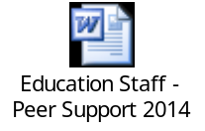

Issue 03 March 2014 Central Parenting Team
N E W S L E T T E R
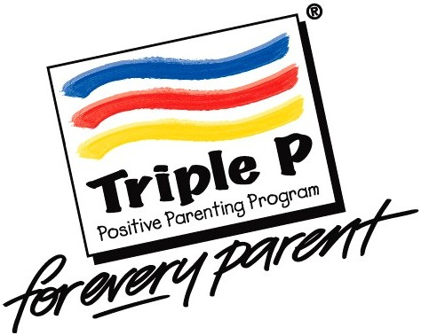

The Central Parenting Team are:

Marie-Claire Leese
Parenting Programme Manager (jobshare)
marie-claire.leese@ggc.scot.nhs.uk
07805810738

Wendy Toner
Parenting Programme Manager (jobshare)
wendy.toner@ggc.scot.nhs.uk
07805810742

Louise Gaunt
Parenting Coordinator
(Lead for Housing/Glasgow Life/3rd Sector)
louise.gaunt@ggc.scot.nhs.uk
0141 277 7494

April Montgomery
Parenting Coordinator
(Lead for Education & Social Work Services)
april.montgomery@ggc.scot.nhs.uk
0141 277 7572

Patrick Mandara
Parenting Information Officer
patrick.mandara@ggc.scot.nhs.uk
0141 277 7560

Charlene Hamilton
Administrative Assistant
charlene.hamilton@ggc.scot.nhs.uk
0141 277 7570

Triple P Groups – April – June 2014

The Central Parenting Team have confirmed the next round of Triple P groups (full lists attached below) which will run across the city from April to June 2014 in the following venues:

The West Centre
North West Womans Centre
Keppoch Campus
Knightswood Community Centre
Budhill Family Learning Centre
Dennistoun Library
Balgrayhill Community Centre
Easterhouse Health Centre
Pollok Civic Realm
Pirie Park Primary School
Langside Library
Govanhill Neighbourhood Centre

Please be reminded that all parents MUST be referred to the Central Parenting Team to receive an invite to the groups.

Parents should be encouraged to phone the Central Parenting Team as soon as possible to book their place on the groups once they have received their invite letter.

Please also take the time to read the document attached below ‘Criteria for Group Referrals’ which outlines what a group consists of and what criteria must be met for a referral



N E W S L E T T E R
Please remember: All referrals should be emailed to: centralparentingteam@ggc.scot.nhs.uk
Real parents, real thoughts

“If you follow through with the strategies, being consistent does make a difference to your parenting”.

“Found programme very helpful. Before beginning parenting programme quite stressed, now I can manage my anxieties better”.

“Have enjoyed being able to use different strategies. Feel more confident in using Triple P”.

“Programme has been very helpful. Should have done it long before now and would encourage other parents to come and use it”.

